Homework
Check out our school website :
Don’t Forget to Have your child bring in an 8 by 8 piece of Flannel!
Looking for pringle chip containers, please send lids as well.

Our Grade Two News
Communicator 14 Oct, 2014

je.nbed.nb.ca
- Read Nightly
- Practice-adding doubles to 18.

New sight words:
That, the they,to,was, with, you.
Students can play some great
Math and Language Arts
games.

Guess Who?
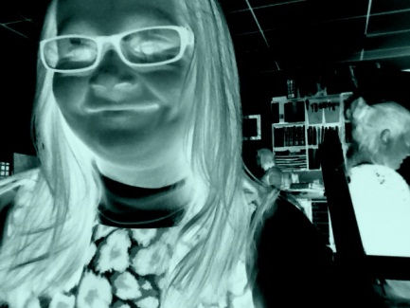
Notes: ____________________________________________________________________________________________________________________________________________________________________________________________________________________________________________________________________________________________________________________________________

Upcoming Events

October 26th Bottle Drive for JES
November 7 JES visits the Robert L Knowles Veterans Unit

