Physical Education: Moving with Purpose
Sun | Mon | Tue | Wed | Thu | Fri | Sat
 |  |  |  |  | 1  Family Fun Friday  Make up a dance. Who has the best dance moves? | 2  Softball Saturday  Act like a pitcher. Practice your underhand throw using a ball or pair of socks.
3  Sunday Special  Go for a walk with your family and try to discover something new. | 4  Make It Up Monday  Make up a game where you must practice your kicking skills. | 5  Toning Tuesday  Cinco de Mayo  5 burpees, 5 push-ups, 5 jumping jacks, 5 lunges & 5 exercises of your own. | 6  Wheelie Wednesday  Review road safety and then skateboard, bike or roller blade.  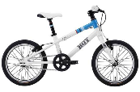 | 7  Tossing Thursday  Toss a ball or pair of socks at the wall. Can you think of 7 different ways to catch it? E.g. 2 hands, clap then catch, etc. | 8  Family Fun Friday  Who in your family can hold a plank for the longest? Side plank? | 9  Skipping Saturday  Go outside and practice your skipping or hopscotch.  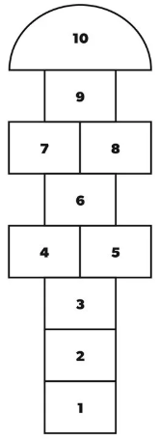
10  Mother’s Day  Do something nice for a special lady in your life. Clean up your space. | 11  Make It Up Monday  Make up a game where you move like different animals? E.g. Gorilla, Fish, etc. | 12  Try-it Tuesday  Find 5 things to go over, under, around and through.  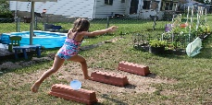 | 13  Wobbly Wednesday  Practice your balance by walking forwards and backwards on a line. | 14  Target Thursday  Set up some toilet paper rolls or items to act as pins. Practice your bowling skills.  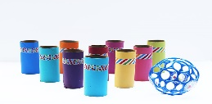 | 15  Family Fun Friday  Who in your family can do the most push-ups? Crunches? Squats? | 16  Softball Saturday  Get 4 items to act as bases & spread them out. Practice running around the bases. How long does it take you?
17  Sunday Special  Spend time with your family playing a game like charades, twister or hide and seek. | 18  Victoria Day  Make up a game where you must protect a Queen or save a Princess! | 19  Toning Tuesday  10 burpees, 10 high knees, 10 squats, 10 crunches and 10 exercises of your own. | 20  Wheelie Wednesday  Review road safety and then skateboard, bike or roller blade. | 21  Tossing Thursday  Toss a ball or pair of socks up in the air. Can you catch it 21 times in a row? | 22  Family Fun Friday  Who can jump the farthest? Highest? Who can hop the fastest? | 23  Skipping Saturday  Set a timer, how long can you skip for? Try again. Can you beat your record?
24  Sunday Special  Go for a walk with your family. Who are 3 special people in your life? Write them a note or draw them a picture. | 25  Make It Up Monday  Make up a dance. Can you include 4 different body parts? High and low movements? | 26  Try-it Tuesday  Create your own obstacle course. Can you include a jumping, throwing and balance activity? | 27  Wobbly Wednesday  Practice your balance. Try balancing on your knees, one foot, or your belly. How long can you balance? | 28  Target Thursday  Set up some targets (e.g. toilet paper rolls or water bottles). Practice kicking a ball or pair of socks to knock them down. | 29  Family Fun Friday  Who in your family can juggle? Who has the coolest trick? | 30  Softball Saturday  Play a game of softball. Use a pair of socks as a ball, your hand as a bat and items around your home for bases.
31
Sunday Special
Pick one special activity to do with your family.

