K/1 Choice Board for At Home Learning
November 1st – 5th, 2021
Literacy | Numeracy | Exploration
Watch/listen to the Jolly Phonics story about the short sound /i/ on youtube – search Jolly Phonics - /1/ Sound – Short Story (0:55). Then listen to the song. Search - Jolly Phonics Song – i (0:14)  Practice printing /i/ in your sound duotang and color the picture (you can work on the other sounds we did as well /s/ /a/ /t/)  For grade one this is a review. | Math by Myself: Sort your Halloween candy. How did you sort it? By color? By type of candy?  Now count your piles to see what you have the most of, the least of, and do you have any that are the same amount. | Playdough fun:  Practice spelling your name. Practice making/spelling your word wall words if you are in grade one and letters in Kindergarten.  After, make something cool with your playdough!
Play Squiggle Park on your tablet or computer | Math with Someone: If you have a deck of cards play 1 Through 10. Take out the face cards (keep the Ace). Spread 10 cards out like a ten frame. 5 in the top row and 5 in the second row face down. | Go outside and play!  You can even ask your parents if you can rake the leaves if you have any on your lawn
Listen to Reading:  Go on Epic! On your tablet or computer.  www.getepic.com/students  enter class code: DMZ9608  select your name | Math in Writing:  work on the math worksheets (might be too difficult for K’s) | Lego – if you have some lego or other types of blocks at home make a haunted house
Work on Writing: Make a card for someone to spread kindness. Don’t forget to write To and the person’s name and From and your name. Tell them something in the card. | Math with Technology:  Play Dreambox on your tablet or computer. | Grade One Challenge:  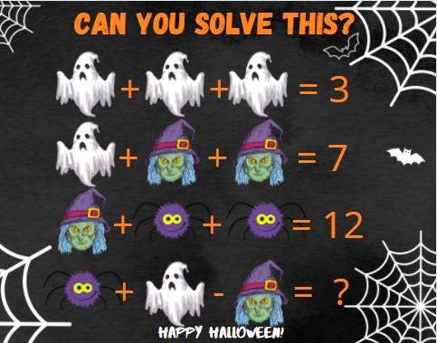
Read to Self:  Gather some books and find a nice cozy smart spot and read. Remember the 3 ways to read a book: Read the Pictures, Read the Words, Retell the Story.  15 minutes or you can Read to Someone: gather some stuffies and read to them. | Math by Myself:  Play Shake ‘n Spill  Put some counters in a cup and shake and spill them out. Write how many red you have and how many yellow and how many in all. Write a number sentence (3+2=5)  If you can’t write your numbers you can draw the counters. | Cosmic Kids Yoga  Search Cosmic Kids Yoga on youtube and you get to choose which one you’d like to do! There are a couple of Halloween ones (I wouldn’t choose one longer than 23 minutes)

Try to do about 45 minutes of literacy and 45 minutes of numeracy and 30 minutes of outdoor play each day. I miss you already!
You are Kind, Brave & Awesome!
Love,
Mrs. Daley

