K/1 Choice Board for At Home Learning #2
November 8th – 12th, 2021
Choose 1 activity from each category every day if you can.
Literacy | Numeracy | Exploration
Kinders: Watch/listen to the Jolly Phonics story about the sound /p/ on youTube – search “Sound p Story | Letter P story | Jolly Phonics |Then listen to the song. Search – “Jolly Phonics Song – p”  Practice printing /p/ in your sound duotang and color the picture (you can work on the other sounds we did as well /s/ /a/ /t/ /i/)  You can do more sounds if you wish to. | Math by Myself:  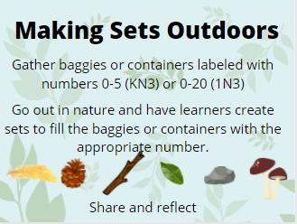 | Art:  Watch: Remembrance Day 2021 for Kids by Miss Ellis on YouTube.  Then make a poppy for Remembrance Day with materials you find around your house. Use your imagination and send me a picture if you can, I’d love to see them!
Play Squiggle Park on your tablet or computer. Squiggle Park is excellent for literacy learning! | Math with Someone:  Play a game with someone that has dice or numbers or shapes. Such as Monopoly, Snakes & Ladders, Connect Four, or Trouble.  And/or do a puzzle | Brain Break/Body Break  www.GoNoodle.com  click on channels and then choose Blazer Fresh – click on videos and scroll down to Meow Moo Moo and play that one.  You can choose after that.
Listen to Reading:  Go to https://storylineonline.net  And watch/listen to Turkey Trouble | Math in Writing:  Grade 1: work on the math worksheets  Kinders: practice printing the numbers 0 to 5 (you can go to 10 if you wish) | 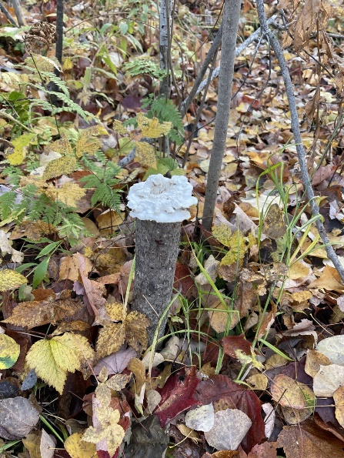
Work on Writing:  Go to the toddparr.com website. Click on Todd TV and scroll down to The Peace Book by Todd Parr 2019  Watch and listen to Todd read his book “The Peace Book”  What does peace mean to you? Write “Peace is _____________” and fill in what peace means to you and draw a picture to go with it. | Math with Technology:  Play Dreambox on your tablet or computer.  Dreambox is excellent for math work | I took the picture above on our trail. What do you wonder about in this picture? What do you notice? What do you think the white stuff is?
Read to Self:  Gather some books and find a nice cozy smart spot and read. Remember the 3 ways to read a book: Read the Pictures, Read the Words, Retell the Story.  15 minutes or you can Read to Someone: gather some stuffies and read to them. | Go on a Math Walk or a Math Drive. Do you see shapes, numbers, or patterns on your drive or walk?

Here are two Literacy Choice Boards that you can choose from as well. The first one is for Kindergarten and if you keep scrolling down you will find one for Grade One. Please note that you can do the K one for your grade one child as well and perhaps vice versa.

Kindergarten
Literacy Learning Choice Board

Phonological Awareness  Read the poem (found below) Then stomp the words that rhyme. | Phonics  Ask your child to say the beginning sound for the following words:  cat, house, candy, basement, gate, ball | Fluency  After reading the poem a few times, ask your child to chime in for a shared reading. Have your child point to each word as you read it.
Phonological Awareness  Ask your child which word does not belong?  cat – bat- broom  fun-treat-run  house-mouse- witch  pig-ghost-wig  hot-pot-chips | Phonics  Ask your child to pick a number (1-6) in race to read (found below) and then read the letters in that row. | Comprehension  Ask your child to retell the main idea of the poem and to draw a picture.
Vocabulary  With your child, go on a nature walk and ask them what they saw first, second, third etc… | Phonics  Ask your child to pick a number (1-6) from race to read and they can practice printing those letters in that row. | Comprehension  Ask your child “what do you think is going to happen when all the leaves turn brown?”

Poem
No tree was empty,
No green in sight,
Until a little leaf
Grew at night.

It was green,
Then changed to red,
Turned dark brown,
And fell on my head.

Race to Read
1 | C u h j k o P Q r
2 | d E I M S t G Z
3 | T p v f H m W x
4 | k D z i J L b y k
5 | r U g V A w x y a
6 | e I N c F s B R q

Grade One
Literacy Learning Choice Board
Phonological Awareness  Read the poem together (found below) and highlight the rhyming words. Ask your child to give you another word with the same final sound. | Phonics  Ask your child to pick a number (1-6) and have your child use a flashlight to read the letters in that row from Race to Read (found below). | Fluency  Read the sight word list below to develop fluency.
Phonological Awareness  Sort these words into the appropriate category  at op  Words: sat, rat, cat, splat, hop, mop, pop, shop  Can you think of more rhyming words that would match either category? | Phonics  Ask your child to change one of the sounds and tell you the new word:  fall – change the “f” to a “m” and what do you get? mall  candy- change the “c” to a “m” and what do you get? mandy  boo – change the “b” to a “m” and what do you get? moo  rat – change the “t” to a “n” and what do you get? ran | Comprehension  Reread your favourite book from your home library or watch your favourite TV show and retell the main events.  B M E  Draw and/or write about the beginning, middle and end parts of the story.
Vocabulary  Ask your child to describe how they make their favourite sandwich. (i.e. first, second, third) | Vocabulary | Comprehension  After reading the poem, ask your child what does the poem remind you of?

Poem
No tree was empty,
No green in sight,
Until a little leaf
Grew at night.

It was green,
Then changed to red,
Turned dark brown,
And fell on my head.

Race to Read
1 | C u h j k o P Q r
2 | d E I M S t G Z
3 | T p v f H m W x
4 | k D z i J L b y k
5 | r U g V A w x y a
6 | e I N c F s B R q

Sight Words

A B C D E F G H I J K L M
a big can do go he I like me
am come here in look my
and is little
at it

N O P Q R S T U V W X Y Z
on play see the we you
she to
said

