2/3 Choice Board
for At-Home Learning
November 1st – 5th, 2021
Aim to spent about 45-60 mins on Math activities and 45-60 mins on Literacy activities each day! Remember to take time to play, make healthy snacks and lunch (and have a treat as well!), and get outside whenever possible. I miss you all and look forward to our Morning Meetings when I get to see your beautiful faces
Literacy | Numeracy | Exploration
Read a book to someone – even your pet! Ask for a flashlight and make a fort to read in | Math by Myself: Sort your Halloween candy. How did you sort it? By color? By type of candy?  Now count your piles to see what you have the most of, the least of, and do you have any that are the same amount? | Go outside and play!  Play a board game!  Bake/cook something with an adult. Write the recipe down and try to double the ingredients!
Listen to Reading:  Go on Epic! On your tablet or computer.  www.getepic.com/students  and follow the instructions in your Tech Flipbook  Log on to Squiggle Park! (Instructions on back of Flipbook) | Math with Someone: Use your wipe off pouch to play Spin and Add with someone! | Art:  Gather some natural objects (already fallen leaves, flowers, stones, pieces of bark). Bring them to a spot on your lawn or driveway where you can lay them out. Can you arrange them to make a picture? What about a pattern?
Work on Writing: Write in your green book and draw a picture to match. Tell me about your Halloween! Want to teach me how to do something? (Minecraft building perhaps?) Write a step-by-step guide for me to follow! | Math in Writing:  Work on your November calendar or Gumball Math. You can also switch the sheets in your plastic protector and try making addition/subtraction families! | Lego – if you have some lego or other types of blocks at home make a haunted house
Oral storytelling:  Can you tell a story with a Beginning, Middle, and End in the correct order? Give it a try | Math with Technology:  Play Dreambox on your tablet or computer. | Outdoor Math Challenge of the Week:  *See image on next page

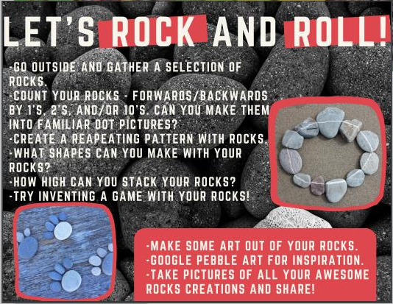
*Challenge: Can you count them by 3’s, 4’s, 5’s, or 6’s? Can you create an increasing pattern? Eg. - 1, 3, 5, 7 (adding two each time)?

