2/3 Choice Board
for At-Home Learning
November 8th – 12th, 2021
Aim to spent about 45-60 mins on Math activities and 45-60 mins on Literacy activities each day! Remember to take time to play, make healthy snacks and lunch (and have a treat as well!), and get outside whenever possible. I miss you all and look forward to our Morning Meetings when I get to see your beautiful faces
*Thursday is Remembrance Day – have a look at these sites on Thursday or before.
8 Things You Can Do For Remembrance Day: https://www.cbc.ca/kidscbc2/the-feed/8-things-you-can-do-for-remembrance-day
Poppy Craft Ideas:
https://happyhooligans.ca/easy-poppy-crafts-for-kids/

Literacy | Numeracy | Exploration
Read a book to someone – even your pet! Ask for a flashlight and make a fort to read in  Word Work:  Sort these words into the appropriate category  ack ock  Words: pack, sack, track, tack, bake, lock, dock, sock, clock  Challenge: Can you add more ack and ock words? | Math by Myself:  You’re all pro’s at Making 10 now! How many ways can you find to make 100?! Write them down and we will share next Monday morning!  Play Hit the Button – try a new game to challenge yourself!  https://www.topmarks.co.uk/maths-games/hit-the-button | Go outside and play!  Play a board game!  Bake/cook something with an adult. Write the recipe down and try to double the ingredients!
Listen to Reading:  Go on Epic! On your tablet or computer.  www.getepic.com/students  and follow the instructions in your Tech Flipbook  Log on to Squiggle Park! (Instructions on back of Flipbook) | Math with Someone: Use your wipe off pouch to play Spin and Add with someone! New game coming on Wednesday! | Art:  Find 4 sticks of about equal length. Find 5 of something (like leaves) and 5 of a different object (pebbles). Create a Tic-Tac-Toe board and challenge someone to a game!
Work on Writing: Write in your green book and draw a picture to match. Tell me about your pet, about your weekend, or anything you’d like to write about! Want to teach me how to do something? (How to score a gol in hockey?) Write a step-by-step guide for me to follow! | Math in Writing:  Work on your November calendar or Gumball Math. You can also switch the sheets in your plastic protector and try making addition/subtraction families! On Friday we will be working on our October weather graph | Lego – if you have some lego or other types of blocks at home make a haunted house
Speaking and Listening:  Watch your favourite movie with someone at home and draw your favourite part. After, write why it is your favourite part.  Make a card or draw a picture for one of our bus drivers, Carl, who just returned home from surgery! | Math with Technology:  Play Dreambox on your tablet or computer.  Website: https://play.dreambox.com/login/knjs/sfcr  Put in class code: 87395  iPad:  School code: knjs/sfcr  Put in class code: 87395  Use your own login info for the rest of the sign in. | Outdoor Math Challenge of the Week:  *See image below

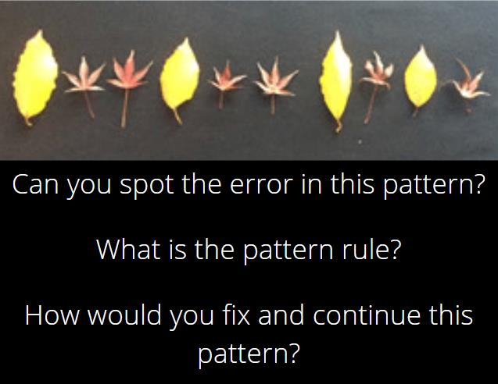
*Challenge – using online tools ( Virtual Manipulatives for Math (didax.com) ) or items at home create an increasing or decreasing pattern. (E.g. – 25, 20, 15, 10, 5, 0 pattern rule is minus 5)

