**Slice of Life Writing Contest**

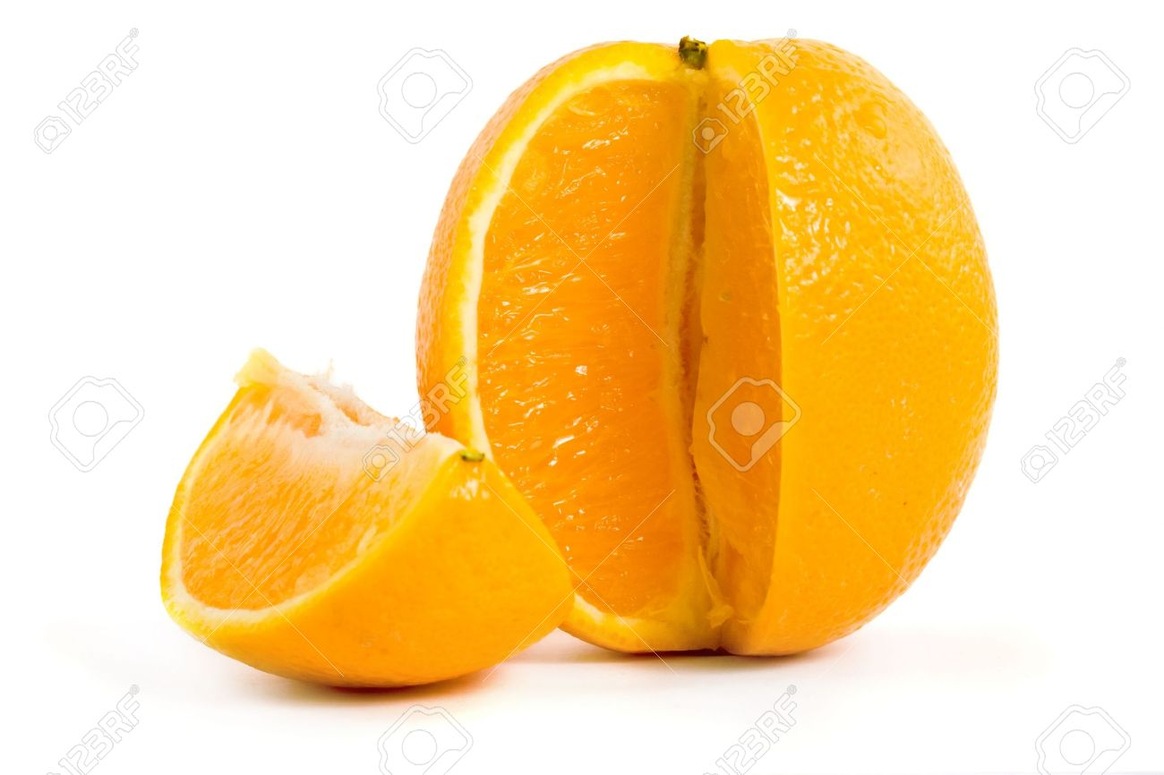

**Students are invited to write a “Slice of Life” story. Each week a story will be selected and read on our website. The winning stories will be published in a book!**

**See Ms Ellis if you have any questions.**

**Good Luck!**